**SPRING CORE AND MAVEN**

**1.Configuring a basic spring application:  
  
pom.xml:**

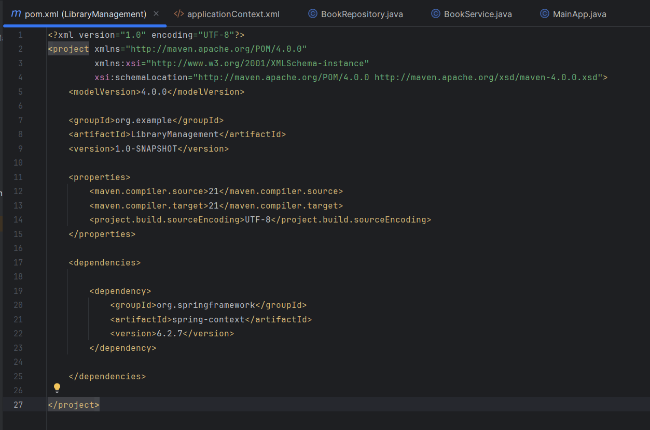

**ApplicationContext.xml:**

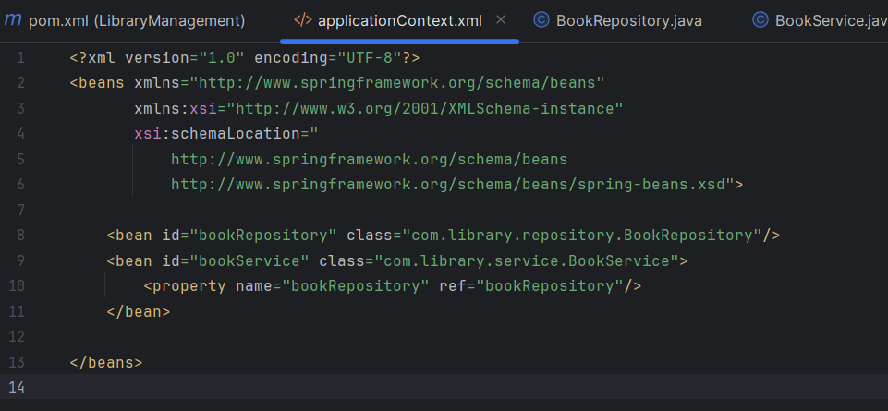

**BookRepository.java:**

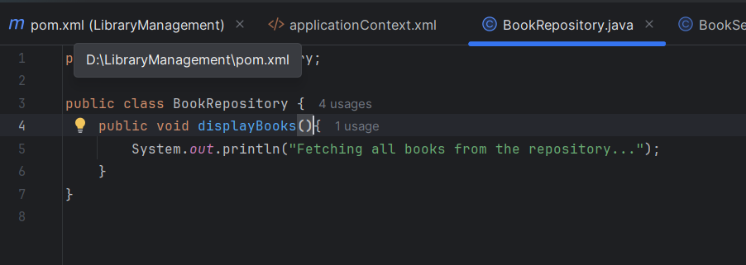

**BookService.java:**

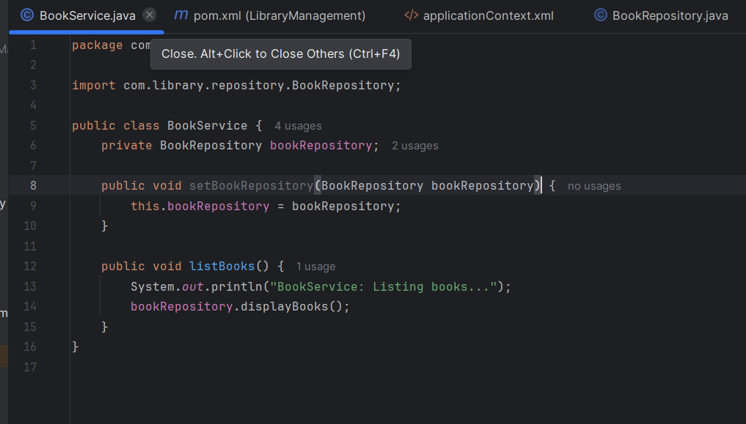

**Mainapp.java:  
  
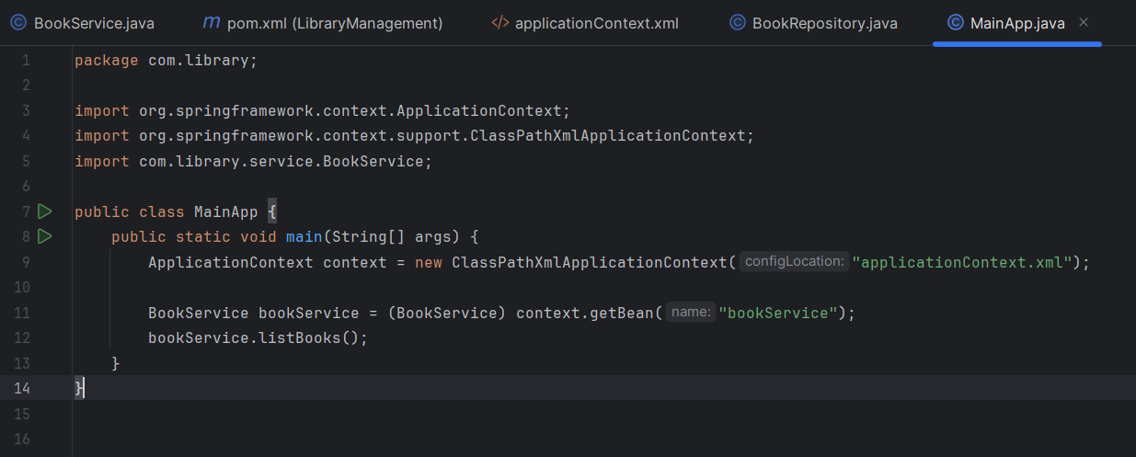**

**OUTPUT:  
  
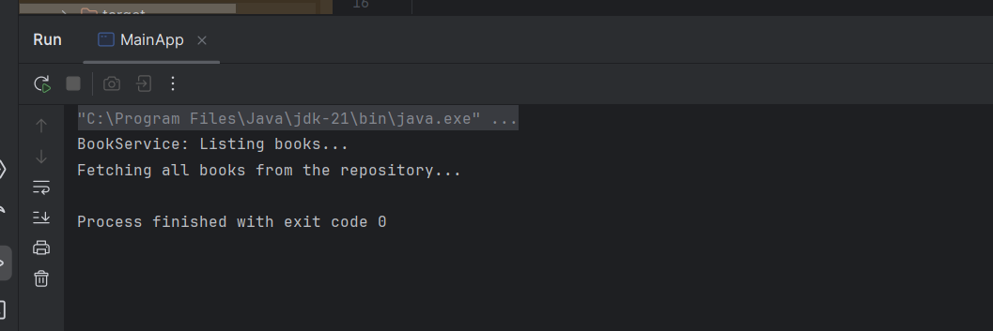**

**2.** **Dependency Injection Using Spring IoC:  
  
pom.xml:**

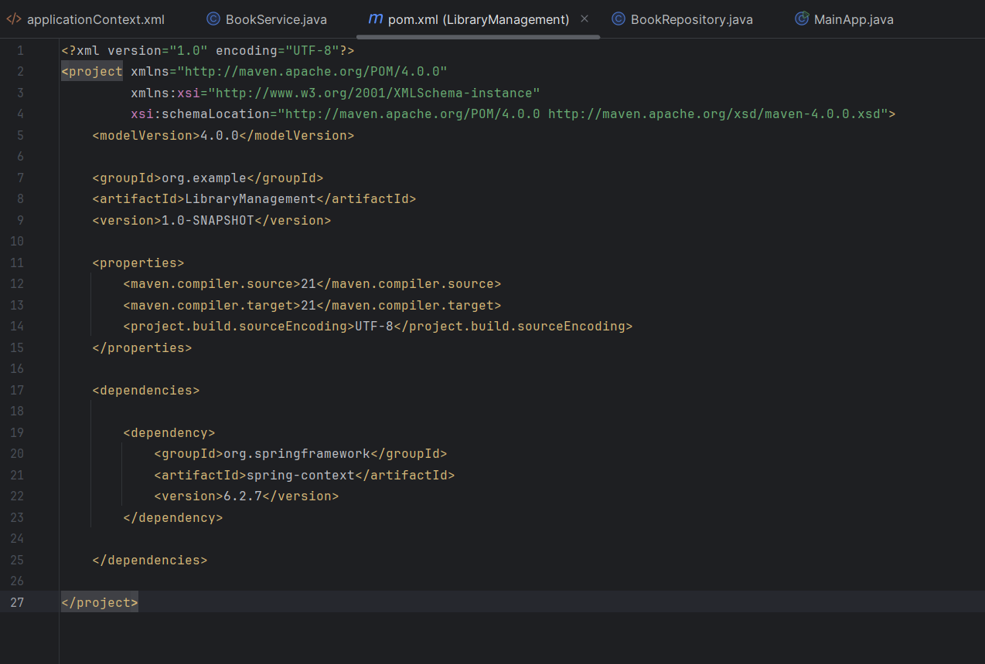

**ApplicationContext.xml :**

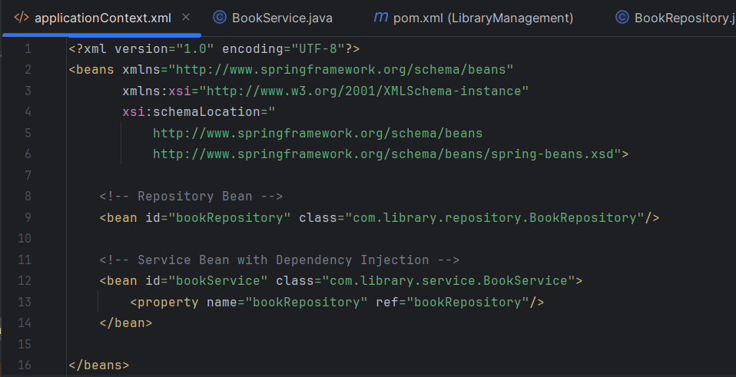

**BookService.java:**

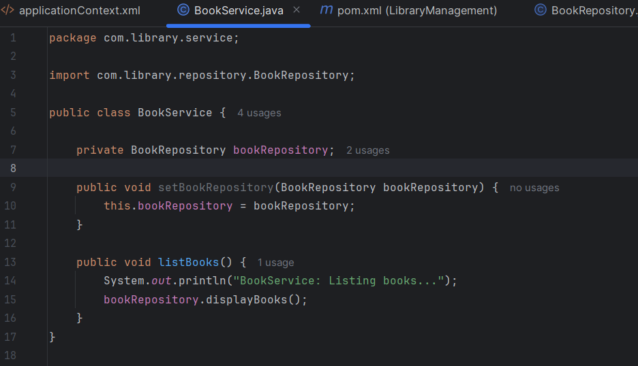

**BookRepository.java:  
  
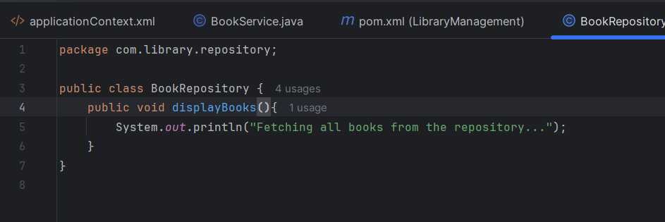**

**MainApp.java:**

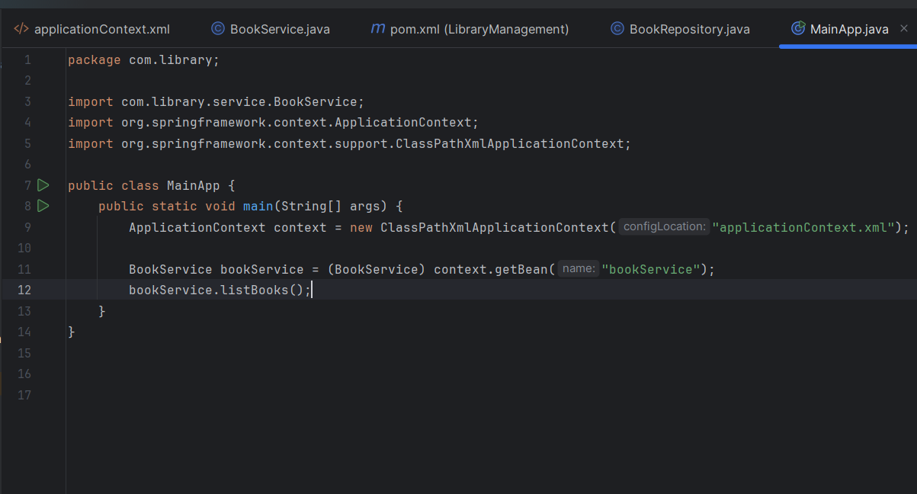

**Output:  
  
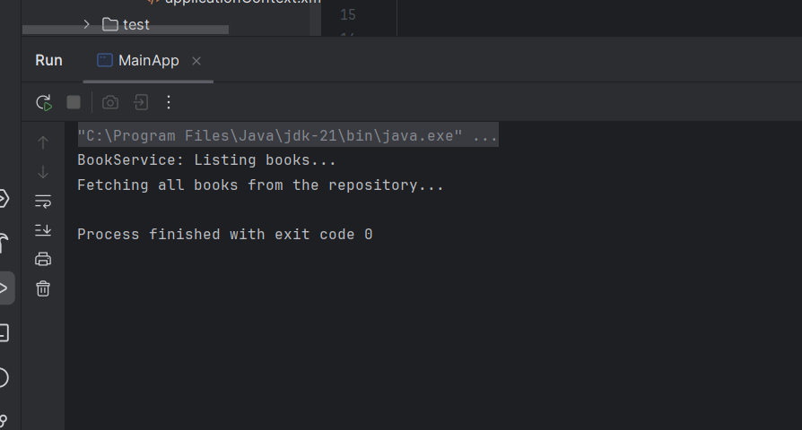**

**3. Creating and Configuring a Maven Project:**

**Adding spring dependencies :**

**Pom.xml:**

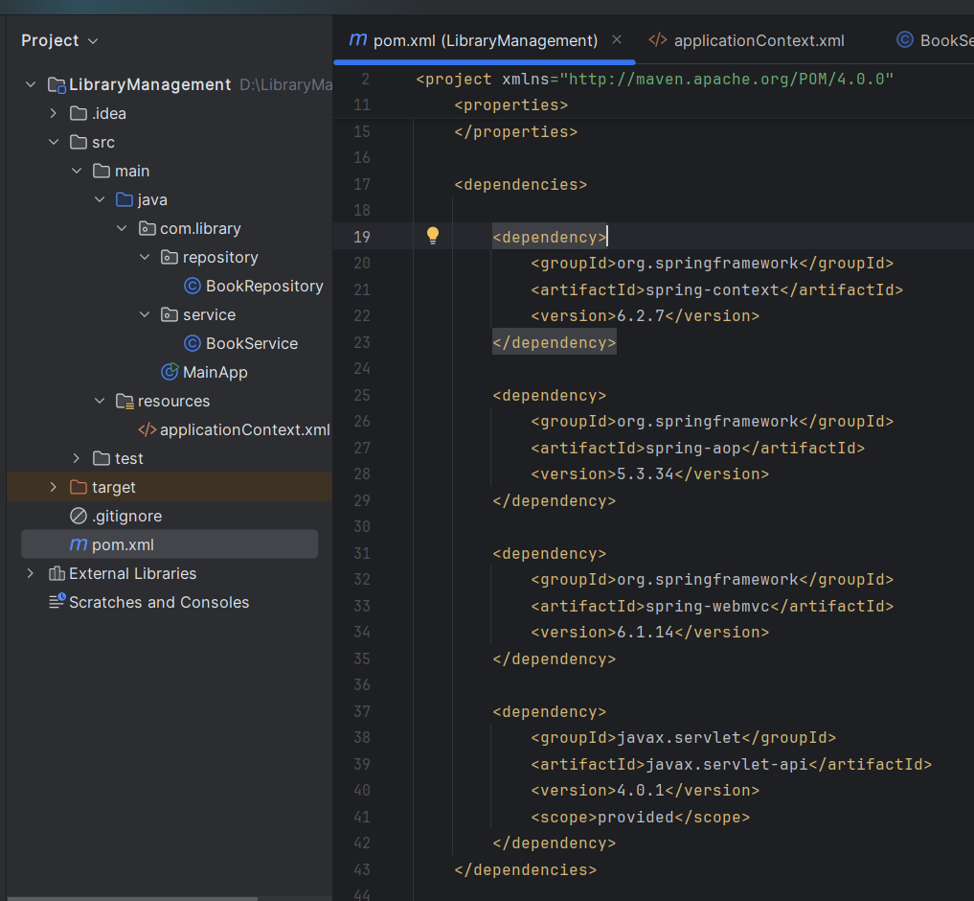

**Configuring maven plugins:**

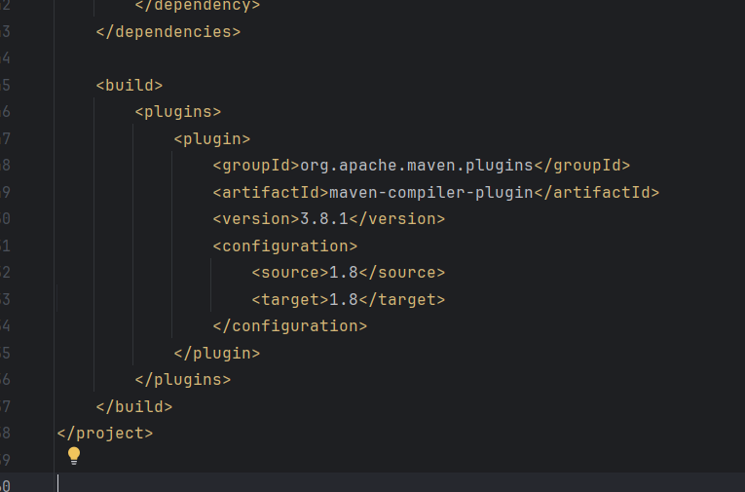

**MainApp.java**

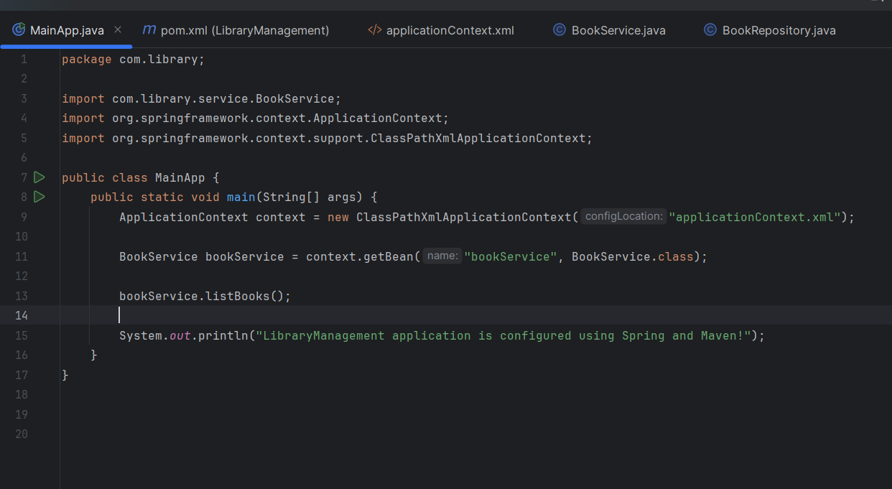

**Output:  
  
